ATTACH THESE PAGES AFTER THE WORKBOOK FROM THE   
CONDUCT A STRATEGY ANALYSIS COURSE

v1.0

# C:\Users\asche\AppData\Local\Temp\SNAGHTMLb059987.PNGThe BA Guide’s Business Analysis Process

## Plan the Project Process



## Important Concepts

Project Manager vs Business Analyst:

Adaptive Methodologies vs Predictive Methodologies:

## Key Terms

Project -

Stakeholder -

Requirements -

# Project Plan Initiation

## The Basics

Goal:

# Step 1: Step 2:

# Step 3:

# 

## Stakeholder Identification

Types of stakeholders could include…

Why identify stakeholders? How to identify stakeholders?

## Project Charter

Project Charters are utilized to:

# 

# 

# 



Notes:

# 

## Arrange a Kickoff Meeting

What is a kickoff meeting?

Arranging a kickoff meeting:



# It is important for project team members to be able to attend the kickoff meeting.

## Conduct a Kickoff Meeting

Steps to Conduct a Kickoff Meeting:

# Notes:

# 

# Requirements Management Plan

## Requirement Abstraction

# Abstraction refers to the of a requirement.

# 

Notes:

Ultimate Question:

## Requirement Storage and Access

# Defines where requirements will be and how stakeholders will them.

# 

Formats and Storage:

Things to consider:

Ultimate Question:

## Requirement Attributes

# Attributes describe the metadata; the about the data.

# 

Notes:

Typical Adaptive Attributes: Typical Predictive Attributes:

Ultimate Question:

## Requirement Reuse

# Requirement reuse is the concept of reutilizing project requirements in .

# 

Notes:

Ultimate Question:

## Requirement Traceability

# The ability to a from the original source through deployment.

# 

Benefits of Traceability:

Common Traceability Techniques:

Ultimate Question:

## Requirements Change Control

  
Allows for projects to remain to ever changing business needs while also taking into consideration the of the requested change.



Adaptive Change Control:

Predictive Change Control:

Ultimate Question:

## Requirements Approval Process

  
Define and requirements are approved by project stakeholders.



Ensure that requirements:



Adaptive Notes:

Predictive Notes:

Ultimate Question:

# Project Plan Details

## Break Down the Project

# Divide the project into to help define how the work with be performed.

# 

Projects can be divided into or .

Chart Mind Map Outline

## Break Down the Project *(continued)*

Steps to Break Down the Project:



Adaptive Notes:

## Break Down the Project *(continued)*

Predictive Notes:

## Set the Project Schedule

# A signifies an important event in the project.



Project Milestone Notes:

# 

S__________________

T__________________

A__________________

R__________________

M_________________

## Set the Project Schedule *(continued)*

# Estimation is the concept of predicting the of .



Estimation Notes:

Adaptive vs Prediction Estimation:

## Set the Project Schedule *(continued)*

Adaptive Estimation Techniques:

## Set the Project Schedule *(continued)*

Predictive Estimation Techniques:

## Set the Project Schedule *(continued)*

# A is the constraint between two activities where one activity

# is reliant on the other being completed, or at least started.



Notes:

## Set the Project Schedule

Setting an Adaptive Schedule:

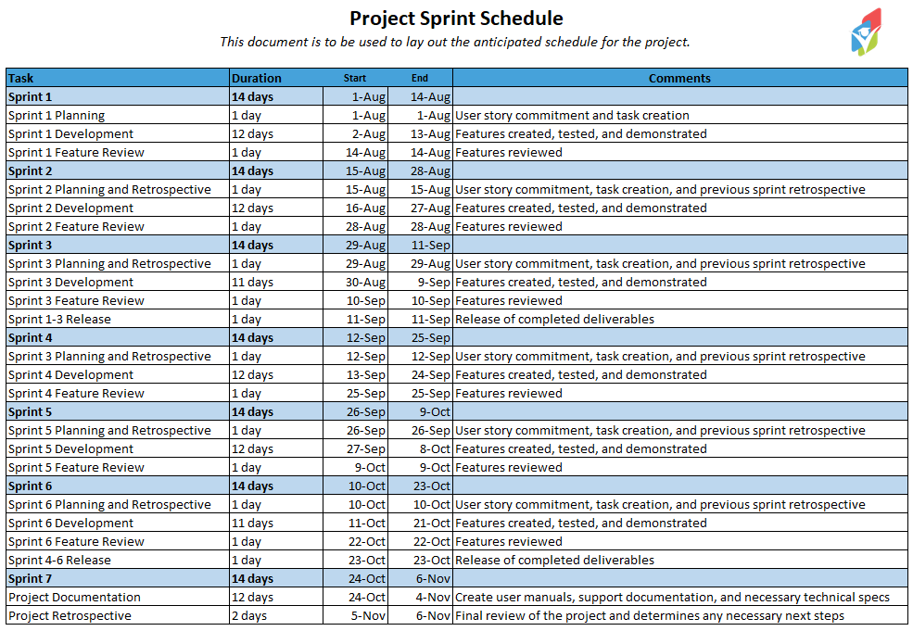

## Set the Project Schedule

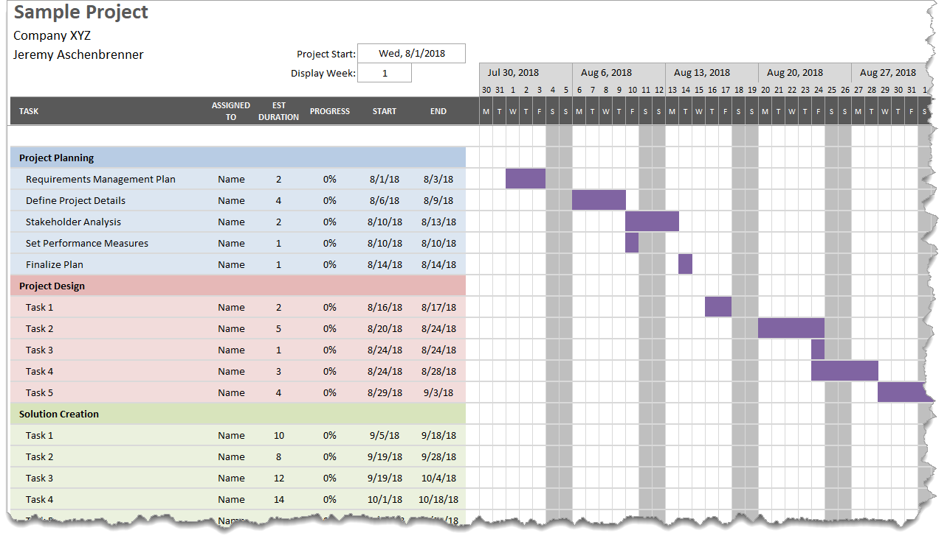Setting a Predictive Schedule:

## Define a Quality Plan

# Outlines the quality , , and quality assurance mechanisms for a project.



Testing and Quality Assurance Notes:

Defect Management Notes:

Training Requirements Notes:

## Release Planning

# Formulate a plan to begin using project in a production environment.



Adaptive Release Planning Notes:

## Release Planning

Predictive Release Planning:

Plan how…



Rollout Options:



Support Considerations:



Details to Hand Over:

# Stakeholder Analysis and Engagement

## Stakeholder Power Interest Analysis



Utilize a stakeholder’s and to appropriately involve them in the project.



Notes:

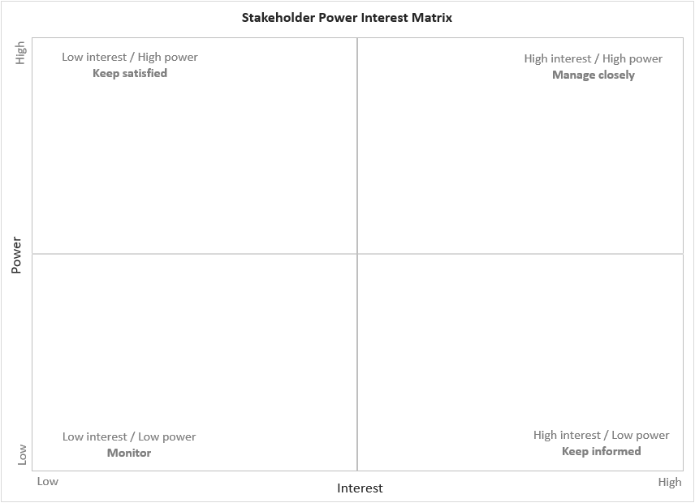

## RACI Matrix



RACI Matrix helps to align the of stakeholders to project .



Notes:

I__________________

R__________________

A_________________

C__________________

Validation:

* At least one person is per task
* At least one person is per task

## Responsibility Assignment Matrix

Notes:

P__________________

S_________________

A__________________

## Collaboration and Communication Plan



Provides guidance on the needs for the project.



Notes:

## Project Performance Measures

Steps to Complete:



Notes:



Notes:

## Business Analysis Performance Measures

Measurables help to:

Steps:



Notes:



Notes:

Notes:

A close up of a sign

Description generated with very high confidence

CONGRATS ON COMPLETING THE

PLAN THE PROJECT COURSE!

Find more courses in this Business Analysis Process Series at:

[www.thebaguide.com/baprocessseries](http://www.thebaguide.com/baprocessseries)